cloudstack management与agent交互
在cloudstack management端，AgentManagerImpl组件负责与agent通信。

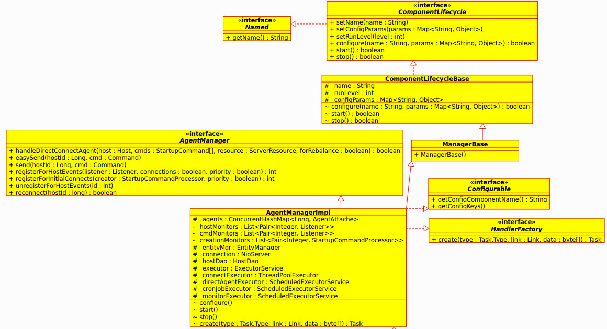

在AagentManagerImpl组件中的configure()中对相关线程初始化
_executor = new ThreadPoolExecutor(threads, threads, 60l, TimeUnit.SECONDS, new LinkedBlockingQueue<Runnable>(), new NamedThreadFactory("AgentTaskPool"));

_connectExecutor = new ThreadPoolExecutor(100, 500, 60l, TimeUnit.SECONDS, new LinkedBlockingQueue<Runnable>(), new NamedThreadFactory("AgentConnectTaskPool"));
//allow core threads to time out even when there are no items in the queue
_connectExecutor.allowCoreThreadTimeOut(true);

_connection = new NioServer("AgentManager", Port.value(), Workers.value() + 10, this);
s_logger.info("Listening on " + Port.value() + " with " + Workers.value() + " workers");

// executes all agent commands other than cron and ping
_directAgentExecutor = new ScheduledThreadPoolExecutor(DirectAgentPoolSize.value(), new NamedThreadFactory("DirectAgent"));
// executes cron and ping agent commands
_cronJobExecutor = new ScheduledThreadPoolExecutor(DirectAgentPoolSize.value(), new NamedThreadFactory("DirectAgentCronJob"));
s_logger.debug("Created DirectAgentAttache pool with size: " + DirectAgentPoolSize.value());
_directAgentThreadCap = Math.round(DirectAgentPoolSize.value() * DirectAgentThreadCap.value()) + 1; // add 1 to always make the value > 0

_monitorExecutor = new ScheduledThreadPoolExecutor(1, new NamedThreadFactory("AgentMonitor"));
在start()函数中对已经连接过的host再次连接（重启），启动NioServer和监视线程池间隔固定时间执行一次监视任务
startDirectlyConnectedHosts();

if (_connection != null) {
_connection.start();
}

_monitorExecutor.scheduleWithFixedDelay(new MonitorTask(), PingInterval.value(), PingInterval.value(), TimeUnit.SECONDS);

return true;
在create函数中创建AgentHandler来处理来自agent端NioClient发过来的NioConnection连接

在agent端会启动agentShell,agentShell读取配置文件agent.properties，从agent.properties文件中读取resource的值，通过反射得到底层hypervisor的资源服务代理类，例如KVM的为com.cloud.hypervisor.kvm.resource.LibvirtComputingResource.
对resource值的每一种hypervisor，启动一个agent组件。

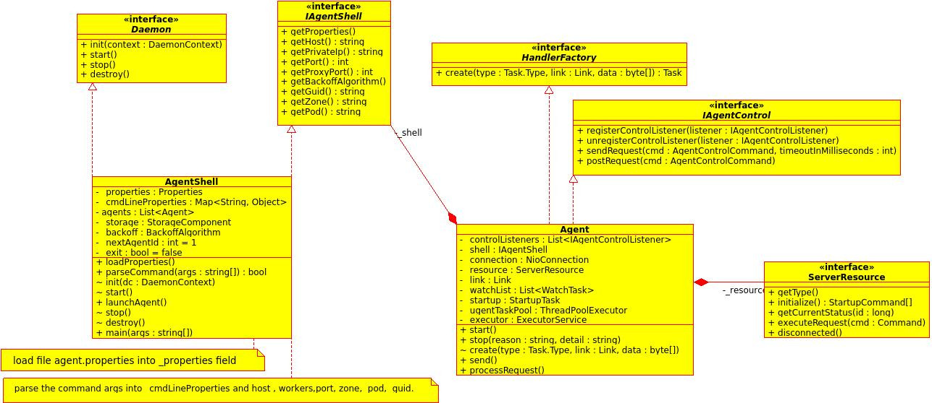

agent组件启动会启动NioClient,NioClient会运行一个Agent-selector的线程运行IO多路复用器/选择器。

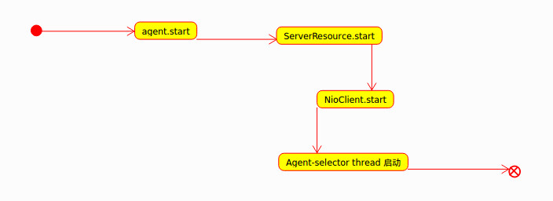
Agent-selector的线程初始运行时执行NioClient的init，NioClient的init方法会创建连接到manager的connect socket，并把connetcSocket register到Seletor,然后创建类型为connect的ServerHandler Task，该类型Task向对端发送StartupCommand request，要求对端(management)发送启动本端的资源(系统VM consoleProxy，secondaryStorage等)。

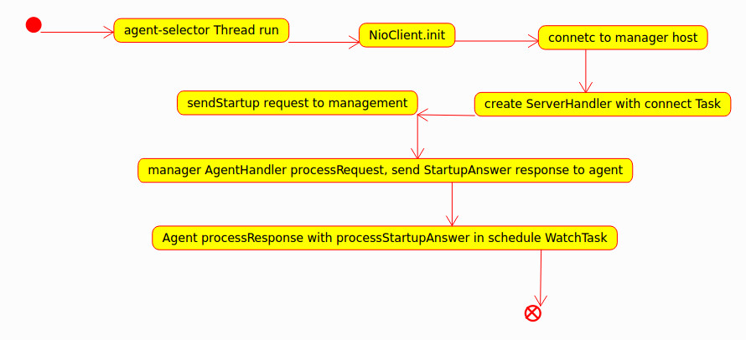

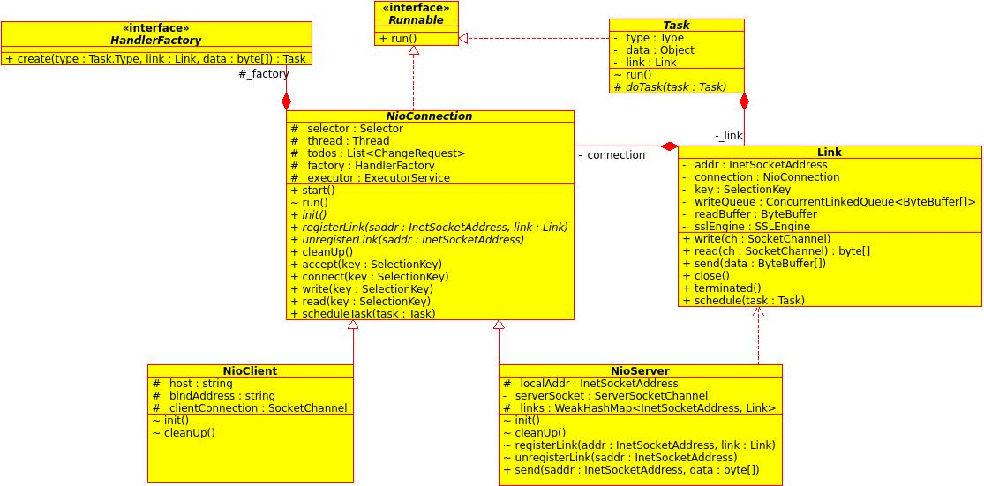

AgentManagerImpl组件与agent组件进行NioClient类与NioSerer类进行异步通信。NioClient类与NioSerer类由Link封装NioConnection进行数据收发。

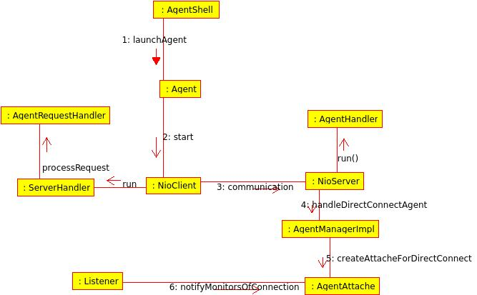

Agent的NioClient创建ServerHandler Task来处理接收对端NioServer发送的request和respone数据，其中在处理接收request数据时创建AgentRequestHandler Task来执行。
AgentManagerImpl的NioServer创建AgentHandler Task处理对端的request和response数据。

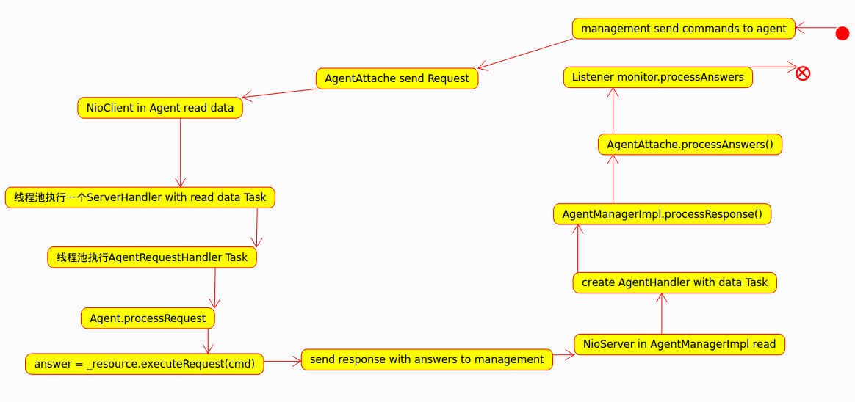

api命令传入ApiServer通过ApiDispatcher调度和AsnyJob管理框架最终执行指定BaseCmd的excute方法，若该命令需要调用agent端，则excute方法会构建特定的command对象，使用AgentManagerImpl的send封装了command对象的request数据给agent端。

